**Group: Gadiparthi, Hoendorf, Kelble, Wadalkar**

**Machine Learning – CS 5137**

**Homework #1 - 9/14/17**

**Homework Description:**

In this assignment you are to implement linear regression in two ways:

1) By using the ideas in my code regression0.m (i.e., using symbolic variables to solve directly for W)

2) By using gradient descent (which computes W iteratively until it finds the solution based on the change in the gradient)

You must submit all the functions + the figures generated by running the program.

You are then to compare the results, which should be pretty close (identical).

The data set: HW1data1.txt contains, in the 1st column the population of cities; the second column contains estimated profit of a company in each city.

**Homework Summary:**

Our group was able to implement linear regression both using gradient descent and using symbolic variables to solve directly for 0. By running the attached Hw1Main.m file, the symbolic variable method was used to find that w0 equals -3.895781 and w1 equals 1.193034, and gradient descent method was used to find that w0 equals -3.630291 and w1 equals 1.166362. The gradient descent method produced this method using the supplied 1500 iterations and an alpha equal to 0.01. By increasing the number of iterations, the gradient descent method results grow closer to w0 equaling -3.895781and w1 equaling 1.193034, which is the same value obtained by the symbolic variable method.

Our final model for the data concluded that for a population of 35,000, we predict a profit of 2798.368764; and that for a population of 70,000, we predict a profit of 44554.546310, with population and profit in terms of 10,000’s and $10,000’s respectively.

**Command Window Output:**

W found by symbolic variables method:

w0: -3.895781

w1: 1.193034

W found by gradient descent method:

w0: -3.630291

w1: 1.166362

Using gradient descent:

For population = 35,000, we predict a profit of 4519.767868

For population = 70,000, we predict a profit of 45342.450129

**Visualization Output:**

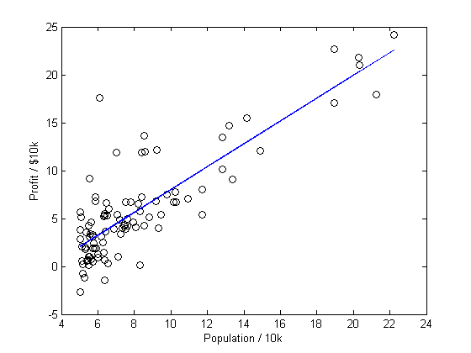

Figure 1: Linear Regression Visualization of symbolic Variable Method Implementation

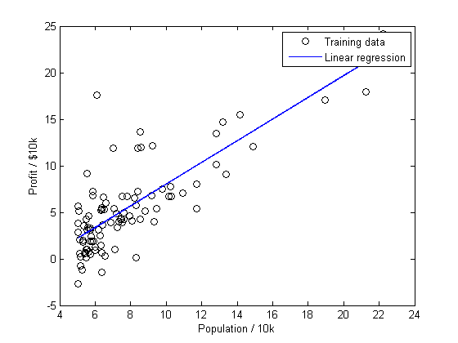

Figure 2: Linear Regression Visualization of Gradient Descent Implementation

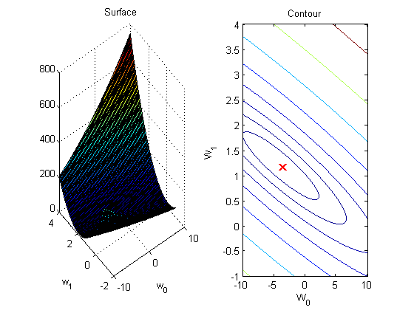

Figure 3: Visualization of the Cost Function

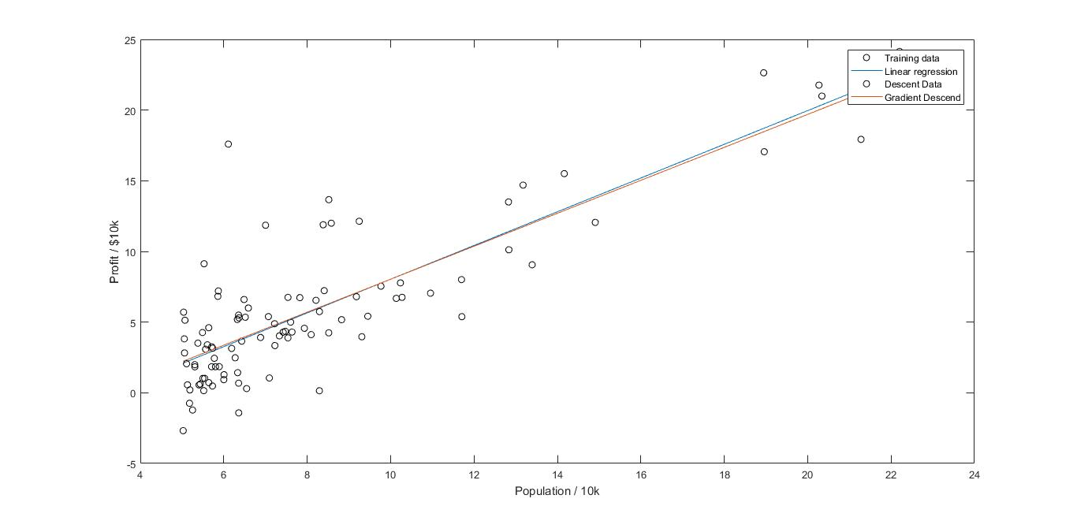

*Figure 2: Linear Regression Visualization of Gradient Descent Implementation*